***Florida International University***

***School of Computing and Information Sciences***

**Feature**

**Document**

**User Story #896**

**Team Member:** April Perry

**Product Owner(s)​:** Gummi Traustason

**Mentor(s)​:** Masoud Sadjadi

**Instructor​:** Masoud Sadjadi

**User Story #896 --** “Pull live STATS from database to populate graphs”

* As a PLAYER, (now that the graphs aesthetics are coded for) I would like to be able to view my LIVE statistics that I have stored in the database, so that I know the graphs that I am viewing on the statistics page are accurate in relation to my individual progress.

### Acceptance Criteria:

1. Graphs are empty and ready to be populated
2. Firebase query returns data
3. The data returned is in the expected format

**Use Case**

1. “Pull live STATS from database to populate graphs”

Participating Actors: Player

Entry Condition: User wishes to view REAL TIME graphs representing the accumulated statistics of their SkillCourt play thus far

Events Flow:

1. Player clicks “View History” button on main dashboard
2. Player can scroll up and down to view different REAL TIME graphs

### Use Case Diagram

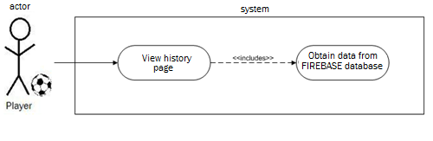

### Sequence Diagram

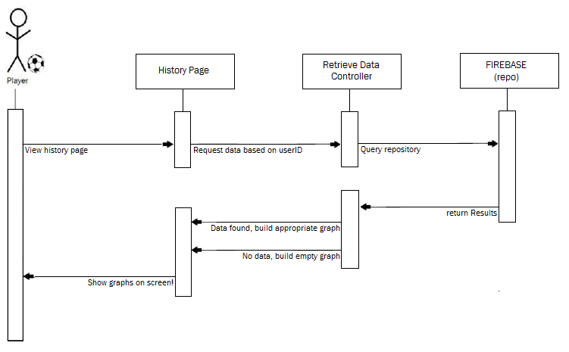

### Class Diagram

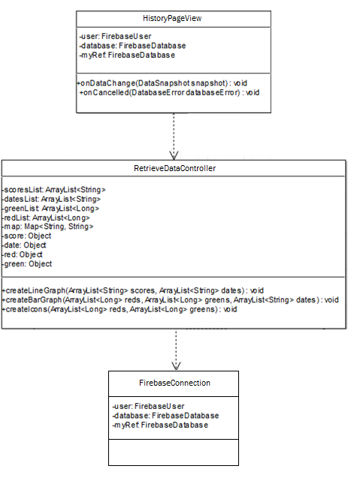

### Unit and Integration Testing

**Test Case 1**

○ *Purpose:* Test the accuracy of the database retrieval for a player  
 that has saved game data

○ *Precondition:* User plays new game and saves results. Then re  
 checks the “History

○ *Expected Result:* The graphs are created with new score intact

○ *Actual Result:* Same as expected.

○  *Status:* **PASS**

**Test Case 2**

○ *Purpose:* Test the functionality of the page if the player has not  
 played any games/saved any results

○ *Precondition:* Player that has not played any games/saved any game data clicks the “View History” button on the main dashboard

○ *Expected Result:* The graphs are created but with no lines/bars/counts. A  
 message with display within them saying no data found

○ *Actual Result:* Same as expected.

○  *Status:* **PASS**

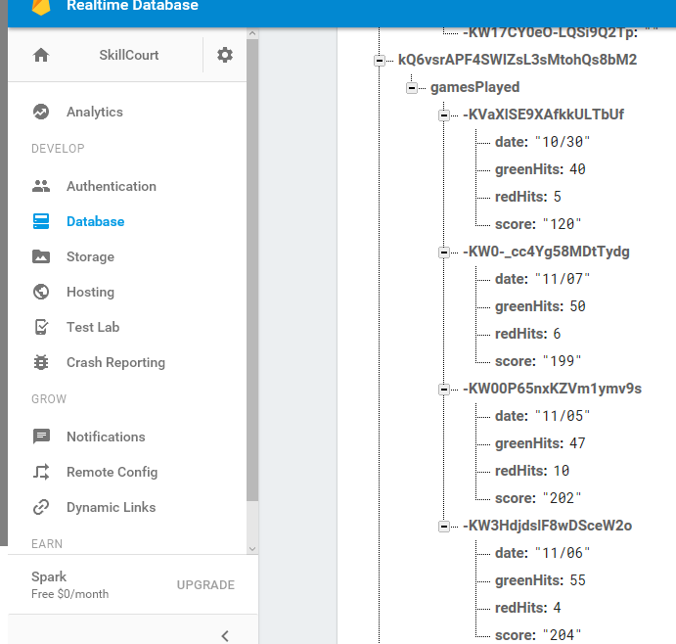**Visual Diagram(s)**

*(Snapshot of our Database 🡪 for comparison*

*to data seen below in graphs!)*

